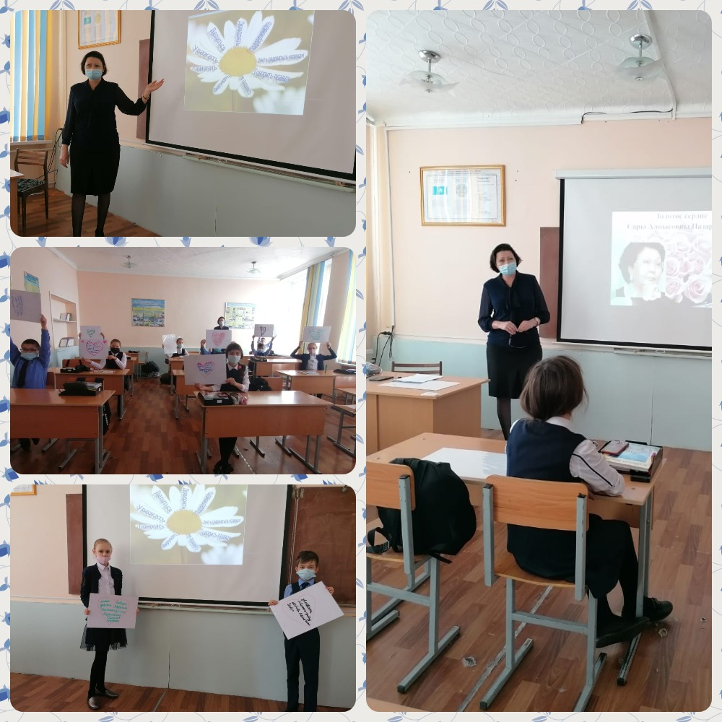

https://www.youtube.com/watch?v=dLS6bzY6LkI&feature=youtu.be

https://www.youtube.com/watch?v=bRdY8e0K0A8&feature=youtu.be

https://www.youtube.com/watch?v=UXvPw-PQrbo&feature=youtu.be
https://www.youtube.com/watch?v=Af2nYOn6BnY&feature=youtu.be

