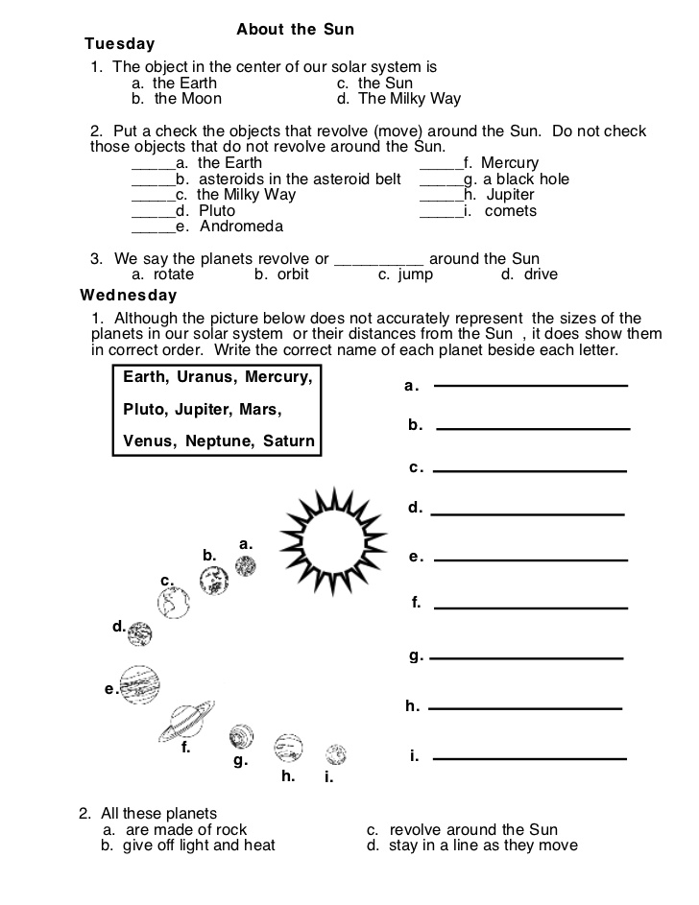
Grade – 4
Theme – Into the Space

bota.adambek@bk.ru
gulnara_08.07.az@mail.ru

