Grade – 5
Theme – World. Present Continuous
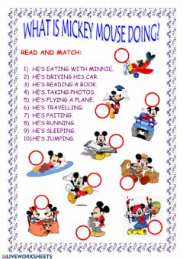
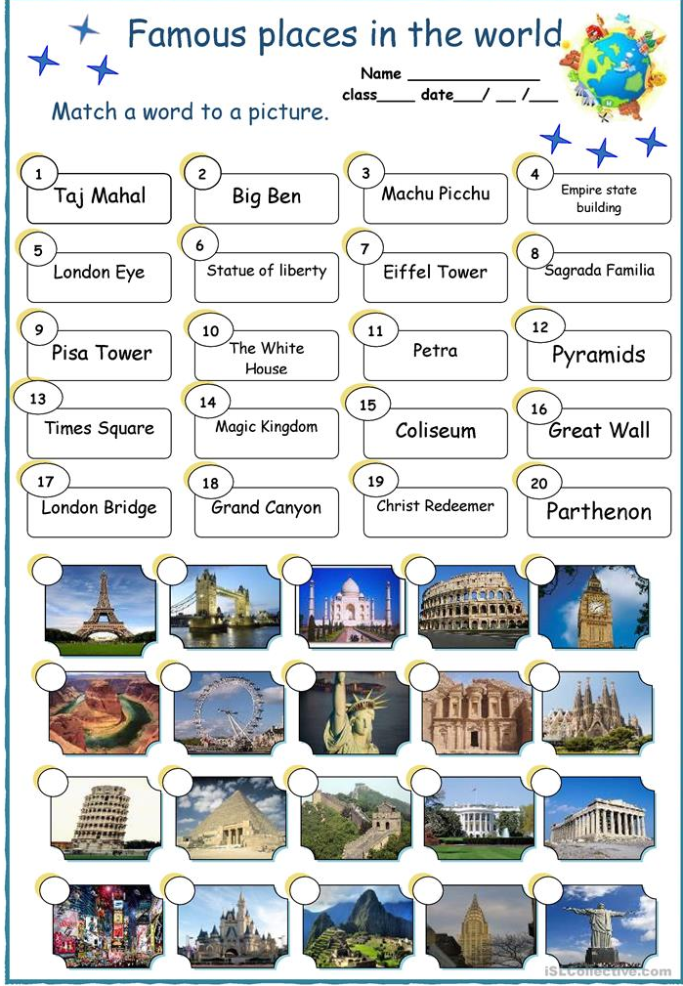
bota.adambek@bk.ru
gulnara_08.07.az@mail.ru

