Theme: Changing seasons
Class: 2

Flash strategy
Teacher shows the picture of the topical vocabulary
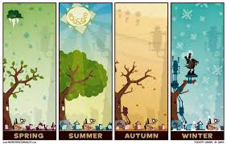

 |  |  | 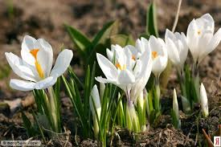
Sun | Leaf | Snow | Flower

https://www.youtube.com/watch?v=WVM9vaYfe58
Task 1.
``Mixed letters`` method
Find the word.
Example: wosn-snow
sipnrgnsu
wrnietlofewr
elfautmanuumsrme
For example: I like spring
Descriptor A learner
-makes words with mixed letters
−reads the words
Task 2. Match the picture with the colours.
IS
Spring is green
Summer is bright
Autumn is yellow
And winter is white
Descriptor:
A learner
-matches the picture
-reads sentences
-describes the pictures

