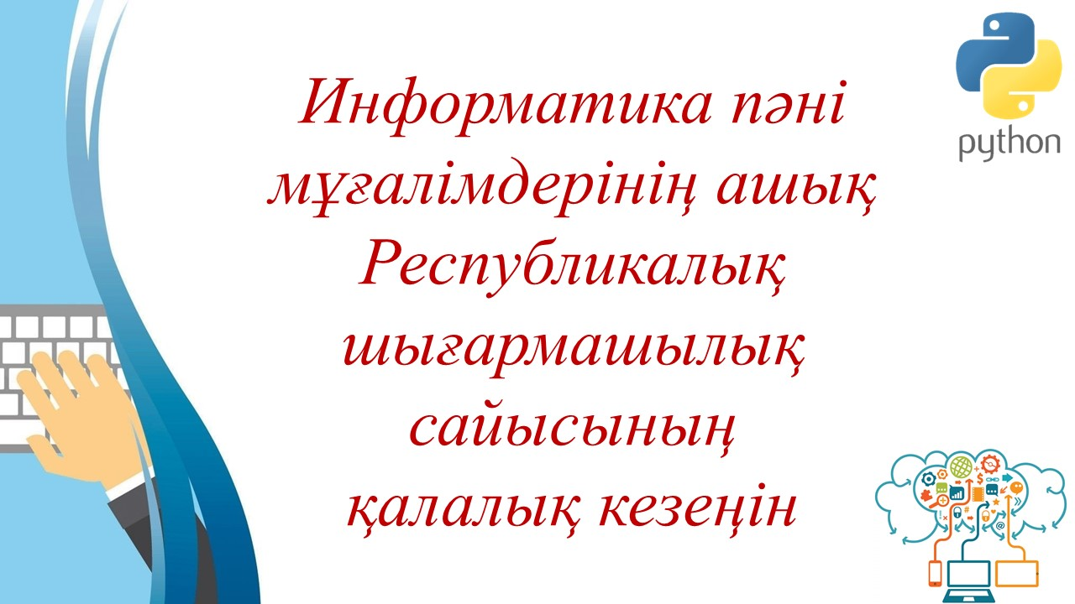
https://www.youtube.com/watch?v=NL3x6YkiOnk

