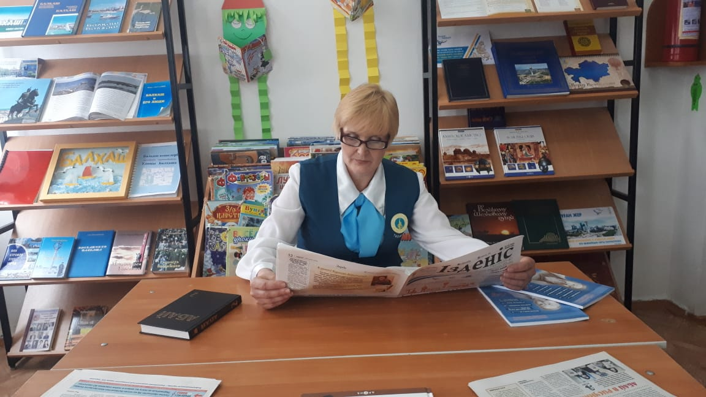

https://www.youtube.com/watch?v=DSHpuN3v7fo

