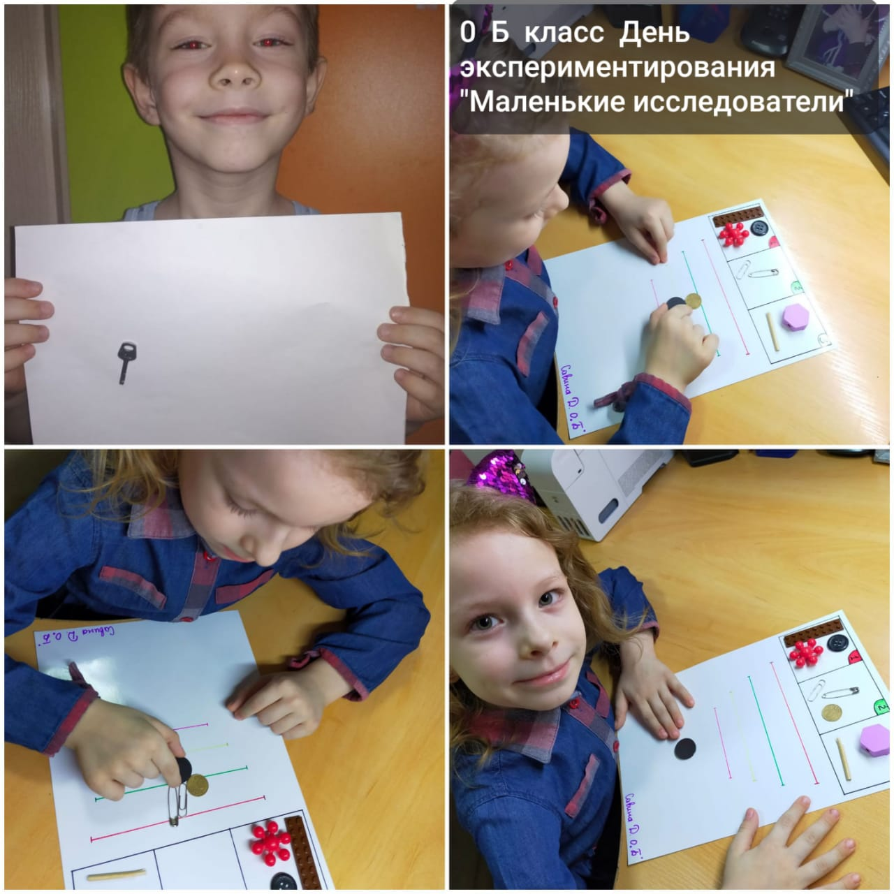
https://www.youtube.com/watch?v=1TlF-Upi73I
https://www.youtube.com/watch?v=kEbc_xnBofY
https://www.youtube.com/watch?v=Anx8Qs85MoU

